## Wei
## Challenge: Big Challenge
### Category: Category

What were we given:
*.pcap

What were we asked to do:
Q1 - 10 points
What service was being scanned?
Q2 - 10 points
What is the IP address of the server?
Q3 - 10 points
What is the IP address of the client?
Q4 - 25 points
How many accounts were successfully verified?
Q5 - 25 points
How many accounts were not verified?

Solve Steps:
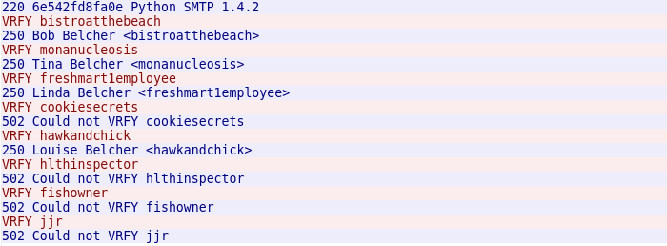
Q1
1. open pcap file in wireshark
2. follow TCP stream
3. I think the service was SMTP
Q2
1. Look for the source of the [SYN,ACK] response
Q3
1. Source of the [SYN] message
Q4
1. Follow TCP stream
Q5
1. Follow TCP stream

